Name:

Causes of Imperialism
Date:

Imperialism is when a powerful and industrial nation takes over a weak and underdeveloped area. Another name for imperialism is COLONIALISM. This name is based on the fact that many powerful nations took colonies during the 19th century.

What were the causes of imperialism? There were many. Some reasons are listed below.
- Industrial nations wanted a place to get raw materials.

- Industrial nations also wanted places to sell manufactured goods.

- Colonies gave powerful nations a chance to have military bases all over the world.

- Many people in the MOTHER COUNTRY wanted to go to colonies to make money.

- The WHITE MAN’S BURDEN was another reason. Most Europeans believed that they had to go to Africa and Asia in order to CIVILIZE the people there. They also wanted to make them Christians.

The greatest imperial EMPIRE belonged to Great Britain. The British described their empire by saying, “The sun never sets on the British Empire.” Countries like Germany and Italy were jealous of England’s great empire. They tried to get colonies for themselves. By the time they got colonies, the good areas were already taken.

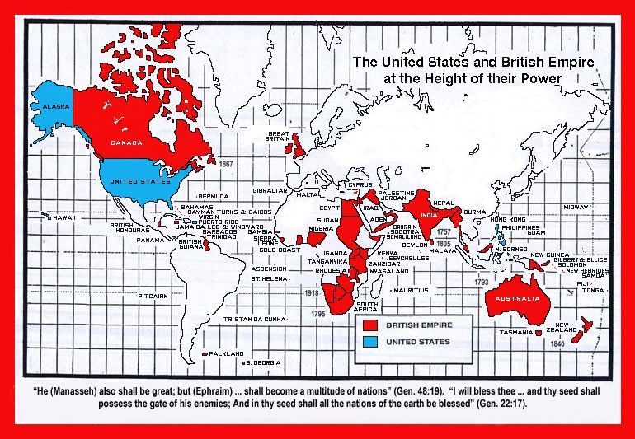

Directions: Use the above reading to answer the questions below.
- List three (3) reasons why the countries became imperialist in the 19th century.

- Which reason do you believe is the most important? Why ?

- Why do you think Italy and Germany did not get the best colonies?

- “The Sun never sets on the British Empire.” What does this mean? Why was England able to get so many colonies in the 19th century?

- Look at the map of the British Empire above. Name four (4) countries and four (4) different continents that were once part of the British Empire.
Colony Continent

1.
2.
3.
4.
1.
2.
3.
4.

