The G’s of Exploration (General reasons for exploring)
- 1. ______________ (spread Christianity)
- 2. ______________ (glory for their country)
- 3. ______________ (discovery for gold and riches)
- 4. ______________ (dominate new territories)

Motives for Exploration (Specific reasons for exploring)
- European countries wanted _______________________ (people and places) to ________________ their country’s goods with.
- European countries were seeking __________________________ not grown or created in their own countries (__________________________________).
- Searching for an ________________________________________ to avoid the Italian traders. (Italians controlled all trade with Asian traders and charged very high prices).
- _________________________________!!! European countries wanted new territories to colonize. The more ________________________ they had, they more _______________________ they were considered!
ESPN-F
- There are only 5 European countries involved in Exploration:
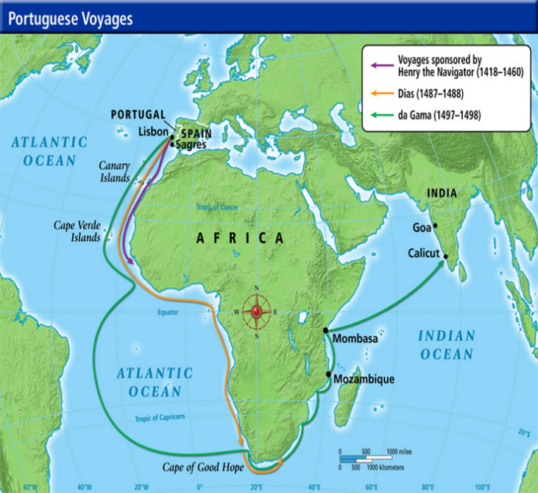
- E - __________________
- S - __________________
- P - __________________
- N - __________________
- F - ___________________
Portugal
- ___________________________________set up a naval research center in 1420.
- He ordered the West Coast of Africa to be mapped, leading Portugal to be ________________________________________________________
Portugal
  - 1488: Bartholomeu Dias explored the _____________________________________________________.
  - 1497: Vasco da Gama rounded the Cape of Good Hope and sailed to India. He _________________________________________________________ first!
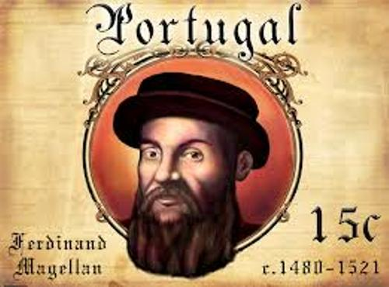
Portugal
- The ____________________________________________ (1493) was an imaginary line running from the North to South Pole. ___________________________ could have what was to the ________________, ______________________ to the __________________.
- Pedro Cabral claimed the land that is now ______________________ in 1500.
- Ferdinand Magellan is the first to sail around the _____________________________.
- He is given credit for ____________________________________ the globe, although he died before they completed the voyage.
Summary Statement for Portugal: ____________________________________________________________________________________________________________________________________________________________
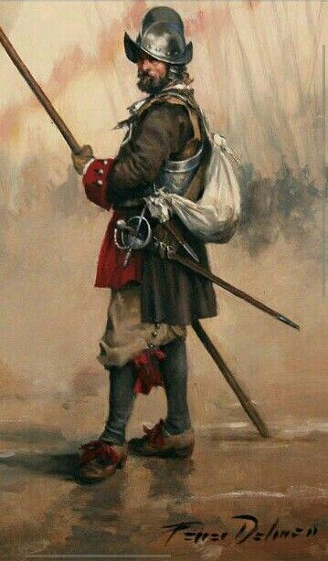
Spain: Christopher Columbus
- An _______________________ sailor who found monetary support from the king and queen of Spain.
- Believed he could reach __________________ by ______________________________.
- Used the Ptolemaic map that was over a thousand years old.
- Sailed west and landed in current day ______________________________.
- Believed he was in the West Indies so he called the Native American people “____________________________.”

Spain
- Spanish _______________________________ (soldiers) used __________________ to take control of the Caribbean Islands, Central and South America, the Southwest region of the United States, and Florida.
Summary Statement for Spain: ____________________________________________________________________________________________________________________________________________________________
England
- John Cabot: Sailing as England’s first explorer John Cabot and his son travelled west and ____________________________________________
- John Cabot disappeared on his second voyage and was never heard from again.
England
- Henry Hudson: An English explorer credited with discovering the __________________________________________________________ (New England)
- The English later explored and settled along the ___________________________________________________________.
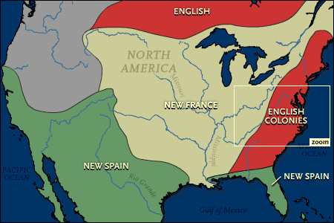
France
- Jacques Cartier: A French explorer searching for a ________________________________________, ended up exploring current day _____________________________.
- Sailed up the St. Lawrence River, thinking he could cross the new world and get to Asia.
- Also claimed present day New Orleans, ________________________.
- France claimed the _______________________________________ (area along the Mississippi River).
- France quit exploring by the mid 1500s due to civil war in their country.

Summary Statement for France: ____________________________________________________________________________________________________________________________________
Netherlands
- The Dutch explored and settled along the Hudson River in ____________________________. New York was originally known as “New Amsterdam,” named for the capital of the Netherlands. They will later give this up to England.
- Dutch established many colonies for trading in __________________________.
Summary Statement for the Netherlands:



