Why did Absolutism end in England?

MONARCHY DEFIES PARLIAMENT
During her reign, Queen Elizabeth I of England had had frequent conflicts with Parliament (the body of representatives that makes laws in England). Many of the arguments were over money, because the treasury did not have enough funds to pay the queen’s expenses.

Elizabeth had no child, and her nearest relative was her cousin, James Stuart. Already king of Scotland, James Stuart became King James I of England in 1603. James inherited the unsettled issues of Elizabeth’s reign. His worst struggles with Parliament were over money. In addition, James offended the Puritan members of Parliament when he refused to make reforms to purify the English church of Catholic practices.

In 1625, James I died. Charles I, his son, took the throne. Charles always needed money, in part because he was at war with both Spain and France. Several times when Parliament refused to give him funds, he dissolved (to break up) it. By 1628, Charles was forced to call Parliament again. This time it refused to grant him any money until he signed a document that is known as the Petition of Right. After agreeing to the petition, Charles ignored it. In 1629, Charles dissolved Parliament and refused to call it back into session. To get money, he imposed all kinds of fees and fines on the English people. His popularity decreased year by year.

Do Now: Use a chart to list the causes of each monarch’s conflicts with Parliament.

MONARCH | CONFLICTS WITH PARLIAMENT
ELIZABETH I
JAMES I
CHARLES I

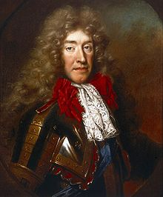
The Petition of Right; the king had to agree to four points:
• He would not imprison subjects without due cause.
• He would not levy taxes without Parliament’s consent.
• He would not house soldiers in private homes.
• He would not impose martial law in peacetime.

Why would Charles I sign the Petition of Right, and then ignore it?

In terms of an absolute monarch, what problems would Charles I have with the Petition of Right?

Why do you think the people of England remained loyal to King Charles despite his disregard for their request for more civil rights?

Charles offended Puritans by upholding the rituals of the Anglican Church (Church of England). In addition, in 1637, Charles tried to force the Presbyterian Scots to accept a version of the Anglican prayer book. He wanted both his kingdoms to follow one religion. The Scots rebelled, assembled a huge army, and threatened to invade England. To meet
this danger, Charles needed money—money he could get only by calling Parliament into session. This gave Parliament a chance to oppose him. Parliament passed laws to limit royal power. Furious, Charles tried to arrest Parliament’s leaders in January 1642, but they escaped. Equally furious, a mob of Londoners raged outside the palace. Charles fled London and raised an army in the north of England, where people were loyal to him. From 1642 to 1649, supporters and opponents of King Charles fought the English Civil War.

ROYALISTS/CAVALIERS  Lead by: King Charles  Supporters: Church of England; Catholics; Nobility; Country Areas  What are the benefits of staying loyal to the king? | ROUNDHEADS  Lead by: Oliver Cromwell  Supporters: Puritans; Merchants; Larger towns and port areas  Why was it dangerous for the people to oppose the king?  Do the benefits outweigh the dangers?  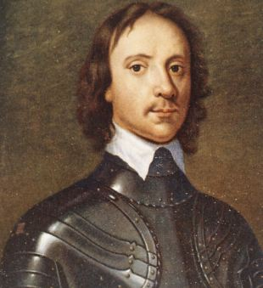

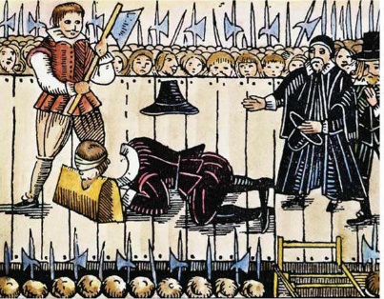
In 1645, Cromwell’s army began defeating the Cavaliers, and the tide turned toward the Puritans. In 1647, they held the king prisoner. In 1649, Cromwell and the Puritans brought Charles to trial for treason against Parliament. They found him guilty and sentenced him to death. The execution of Charles was revolutionary. Kings had often been overthrown, killed in battle, or put to death in secret. Never before, however, had a reigning monarch faced a public trial and execution.

Why was it necessary to execute the King?

Are there any other alternatives?

What did Cromwell’s rule have in common
CROMWELL’S REFORMS

- Cromwell takes title “lord Protector for life”-rules as dictator
- Outlaws sports, gambling, dancing, theatre-going, light colored clothing
- Abolished the monarchy
- Colonized Ireland and crushed Irish rebellion
- Seized Irish land and gave to English soldiers
- Religious toleration for Christians who were not Catholics

with an absolute monarchy?

How did the Glorious Revolution limit British Absolutism?

Civil War Causes Problems in England-You live in England in 1649, right after civil war has just torn the nation apart. Your king, Charles I, was overthrown and executed by the Oliver Cromwell and Roundheads. Oliver Cromwell established a military dictatorship with strict reforms aimed at purifying the nation. Oliver Cromwell ruled until his death in 1658. Shortly afterward, the government he had established collapsed, and a new Parliament was selected. You and the English people were sick of military rule.

What type of government do you believe the new Parliament will establish in England?

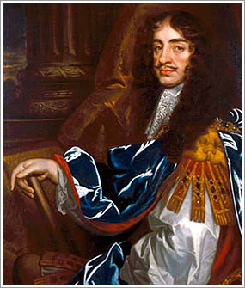
King Charles II Reigns In 1659, Parliament voted to ask the older son of Charles I to rule England. When Prince Charles entered London in 1660, crowds shouted joyfully and bells rang. On this note of celebration, the reign of Charles II began. Because he restored the monarchy, the period of his rule is called the Restoration.

During Charles II’s reign, Parliament passed an important guarantee of freedom, habeas corpus. This 1679 law gave every prisoner the right to obtain a document ordering that the prisoner be brought before a judge to specify the charges against the prisoner. The judge would decide whether the prisoner should be tried or set free. Because of the Habeas Corpus Act, a monarch could not put someone in jail simply for opposing the ruler.

Parliament debated who should inherit Charles’s throne. Because Charles had no legitimate child, his heir was his brother James II, who was Catholic. A group called the Whigs opposed James II, and a group called the Tories supported him. These two groups were the ancestors of England’s first political parties.

Why do you think Charles II accepted the invitation to rule the England after the death of his father?

What was the Restoration?

How did Habeas Corpus protect an individual’s civil rights?

Why did the people have an issue with James II being Catholic?

Activity: Using your notes, draw a timeline recounting the important events from the English Civil War (1642) to the Restorations of Charles II.

THE GLORIOUS REVOLUTION 1688
James II soon offended his subjects by displaying his Catholicism. Violating English law, he appointed several Catholics to high office. When Parliament protested, James dissolved it. In 1688, James’s second wife gave birth to a son. English Protestants became terrified at the prospect of a line of Catholic kings.

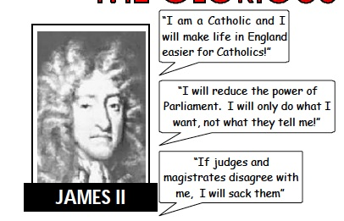
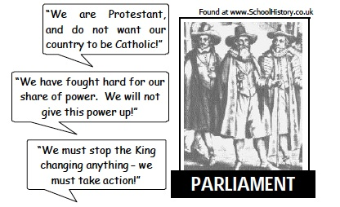

Describe two issues Parliament had with James II.
Issue #1 | Issues #2

Why was Parliament concerned when James II’s wife gave birth to a son?

To many it appeared James was plotting a Catholic take-over. A group of powerful noblemen led by the Earl of Shaftsbury decided it was time to get rid of James: BUT WHAT COULD THEY DO?

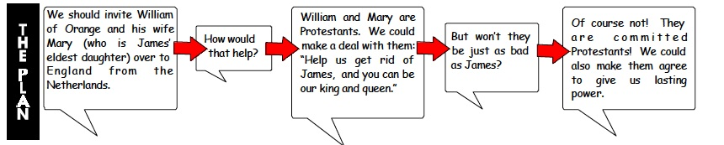

When William led his army to London in 1688, James fled to France. This bloodless over-throw of King James II is called the Glorious Revolution.

How was the overthrow of James II different from the overthrow of Charles I?

William and Mary signed the English Bill of Rights in 1689. They agreed that all future Kings and Queens had to be members of the Anglican Church (Church of England). They also agreed to obey the laws and to leave Parliament alone. England had become not an absolute monarchy but a constitutional monarchy, where laws limited the ruler’s power.

Writing Activity-Imagine you are an undercover newspaper reporter. Write an article describing the key events surrounding the Glorious Revolution.

