Women in Society
- Women in the world have worked to gain _____________________________________________ from the beginning of the twentieth century to the present day.
- __________________________________________ while men were fighting in the world wars.
- The _______________________________ became stronger as many countries around the world, including the United States and Great Britain, gave women the ____________________________.
- _____________________________________________ gave women the ___________________________ and allowed them to hold _______________________
- By the 1920s, more women in democratic nations were entering new professions like _____________________________________________.
Women in Society
- Communist ____________________________________ provided women more equality, encouraging women to ________________________________________.
- The Chinese Communist Party also _____________________________________.
- In the 1960s, the _______________________________ grew in the United States, and women began to demand _____________________.
- These social trends continued to grow worldwide throughout the 1970s to the present.
Women like _______________________ from India,
Corazon Aquino from the Philippines,
________________________________from Myanmar,
Benazir Bhutto, from Pakistan, and
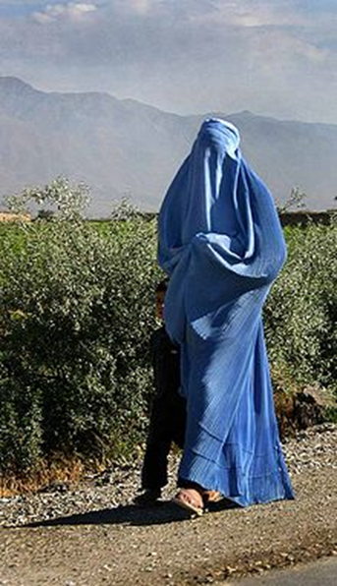
_____________________________ from Great Britain have held _____________________________ in their countries.
Women in Society
- Women have been given more social, economic, and political opportunities but many still face __________________________ in employment and wages.
- Women in ____________________________ and in developing nations around the world have been __________________________________
- The United Nations sponsors many conferences that focus on _____________________________ and issues of human rights around the world.
Science and Technology
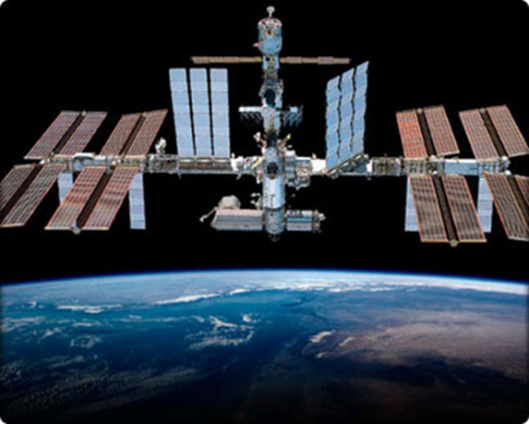
- The ________________________________ between the U.S. and the USSR led to many advances in science and technology.
- The “Race for Space” saw the launching of Sputnik and the Moon landings.
- Afterwards, the U.S. and the Soviet Union both continued technological and scientific advancements in space exploration.
- The _______________________________________________was launched in 1998 by __________________________________ to create a _________________________________________________..
- This and other programs of scientific cooperation between countries continues today.
Science and Technology
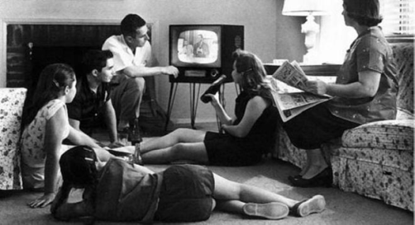
- Many new advances in the area of information, technology, and communication happened in the twentieth century.
- In the 1950s, _________________________________ of up-to-date news and global events.
- This now gives the general public access to important events in the U.S. and around the world like the Civil Rights Movement and the Vietnam or Iraqi Wars.
- The launching of the first __________________________________ have increased _________________________________ as well.
- Events can now be broadcast worldwide, linking countries and people around the world using radios and TV.
Science and Technology
- ________________________ are used around the world to run assembly lines, modern appliances, and assist in business operations using the internet.
- ___________________________ (connected computer networks around the world) _______________________________________ between individuals and allows them to send information to remote locations.
- ______________________ now have access to the Internet, making it even more accessible.
- These new technologies have created an ____________________________________ that depends on modern technology to be successful.
The Environment
- ____________________________________________________________ has hurt the environment.
- Population growth and urbanization has harmed or destroyed many animal and plant habitats.
- _____________________________ that began in the 1960s attempted to ____________________________________________using fertilizers, pesticides, and new strains of crops.
- The result was __________________________________ and lower rates of _________________________as well as an increase in ________________________.
- The downside to the green revolution was the _________________________ released into the environment and increased __________________________________.

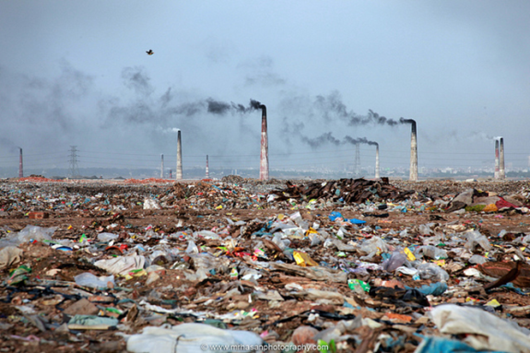
The Environment
- This population growth increased __________________________________________________.
- The UN reports that the number of people who live in cities around the world has quadrupled since 1950.
- Urbanization causes problems of increased ___________________________________________in the cities.
- Both have increased the demand for earth’s natural resources and often leads to pollution.
- ______________________________________ from the burning of fossil fuels such as _________________________________________have caused air and water pollution, __________________________________, damage to the _______________________________ (less protection from harmful radiation), and increased the global warming.
- In 1992, many nations signed the _________________________________, designed to ____________________________ emitted by each country.
The Environment
- Around the world, more people are trying to protect the environment.
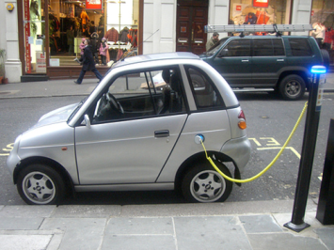
- Many communities use _________________________ to reduce waste and are purchasing products made of recycled materials.
- Other changes such as _______________________________ that use less oil and energy efficient appliances that use less power are being developed.
- The development of alternative sources of energy continues worldwide as well.
- __________________________________________________ are being increasingly used to provide power for homes and businesses.
- _____________________________ is also widely used as a power source today.

